VERONICA SMIRNOFF
The Greater and Lesser Ways
8 February – 4 March 2017
Private View: Thursday 7 February
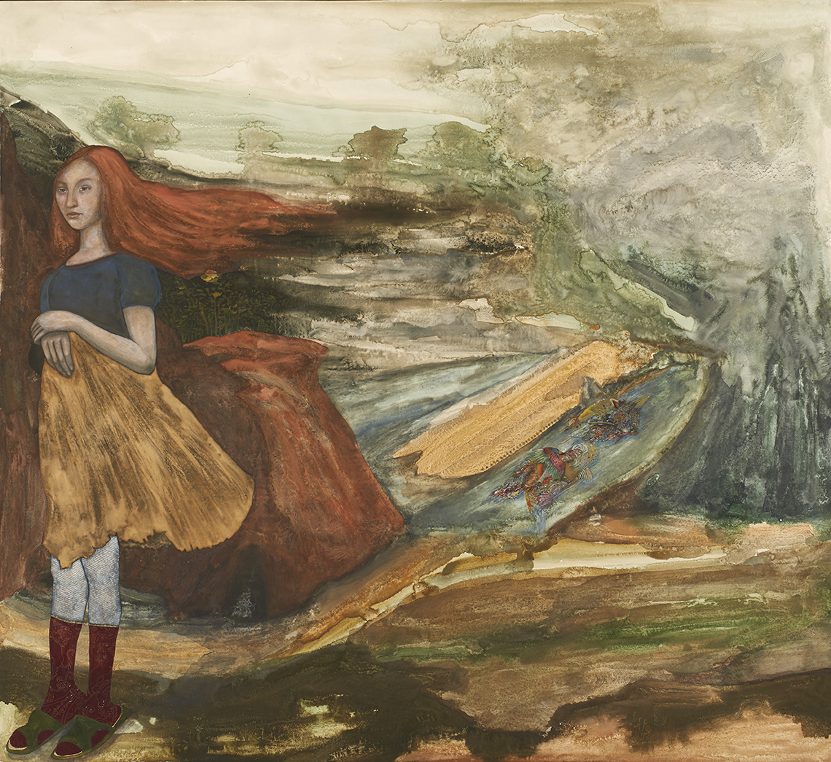

Jessica Carlisle is pleased to announce an exhibition of painter Veronica Smirnoff, opening in February 2017. Exploring various on-going themes central to Smirnoff’s work, in particular folklore, the experience of places, ancient topography and the iconographical elements of imagery, ‘The Greater and the Lesser Ways’ will incorporate a number of new works as well as works not yet exhibited in the UK.
Smirnoff is a London-based artist of Russian origin who cites pre-Renaissance and icon painting as major influences. She is also greatly inspired by folklore and the Russo-Asian tradition. Her figurative works frequently foreground female figures, either in isolation in distinctly pastoral settings, or in groups, assembled in solidarity, wonder or distress. The emphasis on the female figure in Smirnoff’s work allows for an exploration of the multiplicitous experiences of womanhood, while engaging to some degree in autobiographical accounts which remain connected to the artist’s wider subjects of story-telling, memory, myth and identity.
Smirnoff’s technique is similarly steeped in folkloric and popular tradition. Her pigments are made from mixing ground semi-precious stones with wine and egg yolk and she uses oak-supported gessoed panels which are traditionally associated with miniature and icon painting. The panels are prepared and blessed in a Russian monastery, Optina Pustyn in Kaluga Oblast, where the artist recently resided for a period of six months. Smirnoff encrusts the panels with dense layers of pigment that are often sanded down repeatedly to their sedimentary surfaces. This leaves some areas thin and ethereal, emulating a historical lustre that echoes the transmission of folklore and mythology over time.

In Smirnoff’s new work, attention to the volatile water-based properties of paint enhances the main motif of the show. Water is instrumental to Smirnoff’s method; the medium’s fluidity dictates a way of working, in which Smirnoff lays her panels horizontally on the studio floor, applying paint in dots or large blobs, partly giving them over to the mercy of chance. All of the works in the exhibition draw on water-related symbolism in mythology, fairy tales and ancient visual cultures, including the Byzantine folk tradition within which water was commonly associated with metamorphosis. For Smirnoff, water has both a symbolic and a physical significance, as a fundamental component of all life and as an influence on our understanding of space and dimensionality.
Veronica Smirnoff has said:
“Anything big can be also conceived as small and visa versa. Such is the gift of imagination that our perception of greatness and slightness is interchangeable. I am fascinated by this dichotomy. Water is formless but it is moved into form by what contains it. We ourselves are vessels of water. As a substance, water does not in itself attach meaning to largeness or smallness. It just abides. This gives rise to boundless narratives, which weave themselves into my work both consciously and subconsciously.”
Jessica Carlisle has said:
“I have followed Veronica’s work for many years so it is a great pleasure to announce this exhibition. I hope it will introduce many people to the enchanting and unusual work of this talented artist.”
– ENDS –
For further PRESS information, please contact Rees & Company:
Rosanna Hawkins | rosanna@reesandco.com | +44 (0)20 3137 8776 | +44 (0)7910 092 634

About Veronica Smirnoff

Veronica Smirnoff is a British artist of Russian origin (born Moscow, Russia, 1979). She gained a BA from the Slade School of Art and a postgraduate diploma from the Royal Academy of Arts. She had her first solo show with Galleria Riccardo Crespi in Milan (2008) and has exhibited in Moscow, Paris, Berlin, New York and London. She was selected for the John Moores Painting Prize UK (2010) and participated in the 4th Greek Biennale (2013). She lives and works in London.

Exhibition Dates: 8 February – 4 March 2017
Opening hours: Tuesday – Saturday, 12 pm – 6 pm & by appointment
Private View: Tuesday 7 February 2016, 6.30 pm – 8.30 pm
Image: Veronica Smirnoff, Here Be Dragons, 2013, Egg Tempera on Wood, 120 x 130 cm, © Veronica Smirnoff

J E S S I C A C A R L I S L E

4 Mandeville Place, London W1U 2BF
Tel: 07446 482 169 | info@jessicacarlisle.com | www.jessicacarlisle.com

